Week 5
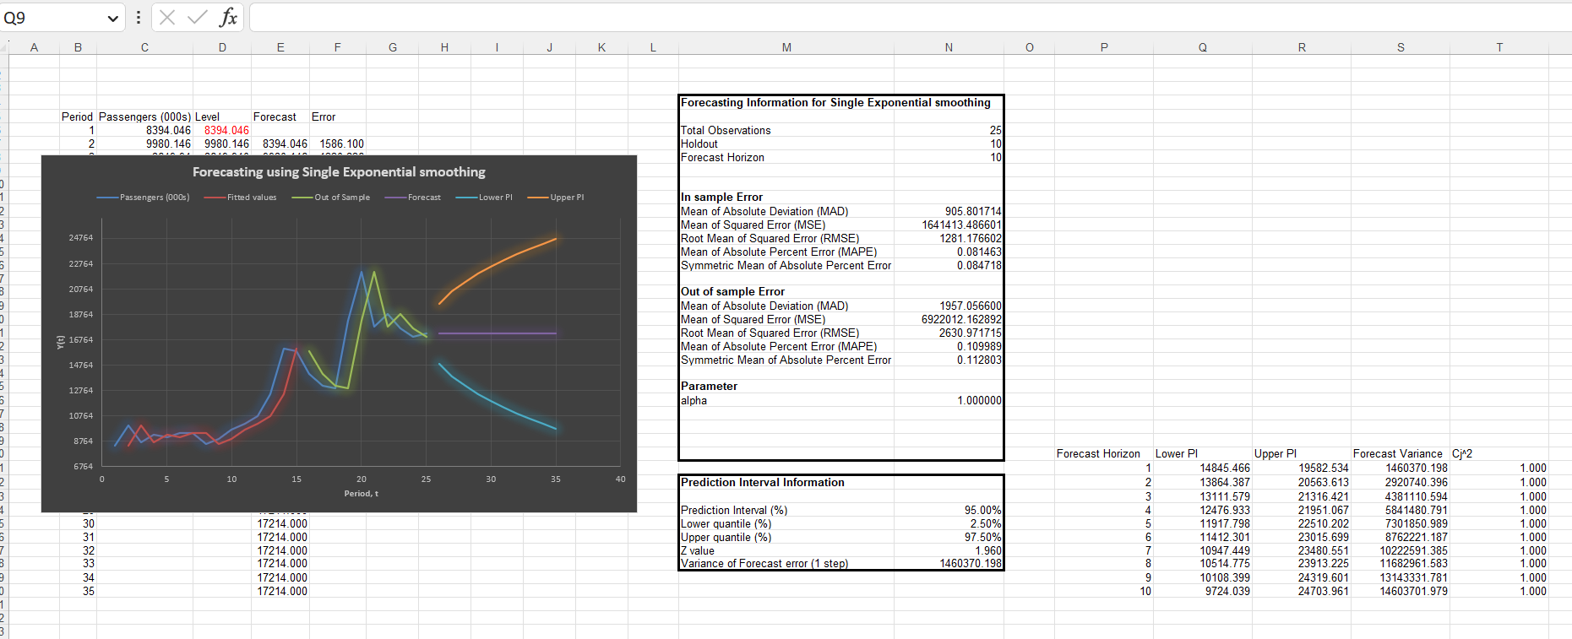

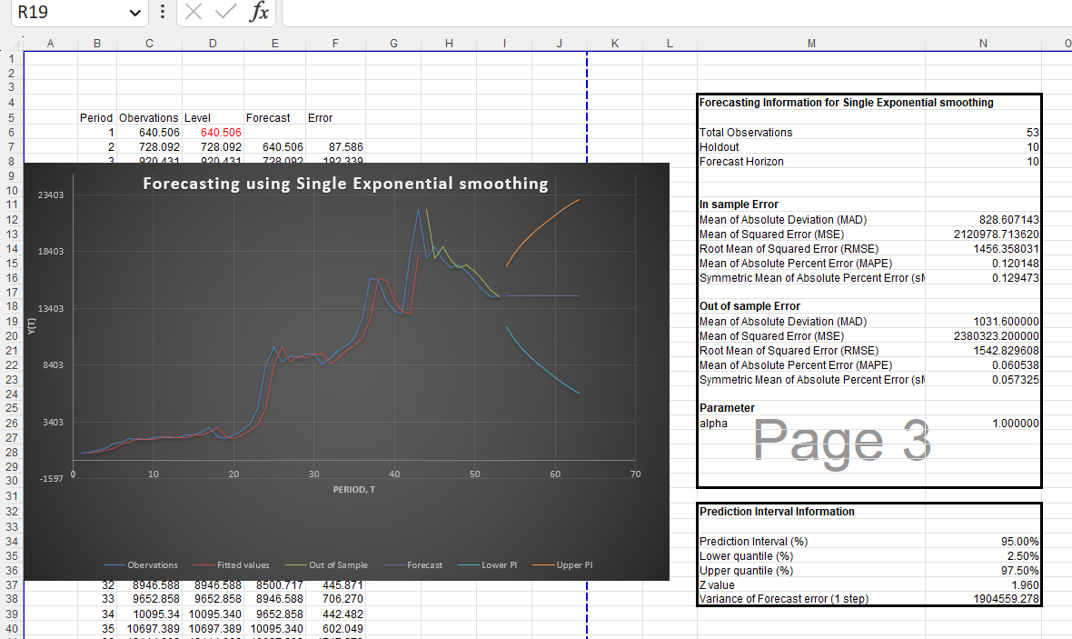

It is clear from comparing the two findings that the forecasting model, which uses the entire dataset, predicts somewhat more passengers for the years after 2010, as opposed to the estimating model. This indicates that the mid-1980s Dulles Airport expansion had a beneficial effect on passenger volume, and the trend has persisted past 2010. Furthermore, the forecasting models for both the estimate and full datasets indicate an upward trend in passenger traffic, suggesting that Dulles Airport has been seeing consistent increases in passenger traffic over time.

